Deploying a Static Website to the Container
(Docker) SOP



Table of Contents

1. Deploying a Static Website to the Container (Docker) 3
1.1 Description 3
1.2 Architecture Diagram 3
1.3 Lab Steps 4
1.4 Troubleshooting 5
1.5 Supporting References 5

Deploying a Static Website to the Container (Docker)

Description
Docker is a tool designed to make it easier to create, deploy, and run applications using containers. Containers allow a developer to package up an application with all of the parts it needs, such as libraries and other dependencies, and deploy it as one package.
In this lab exercise you will learn, how to install docker on an Ubuntu Instance, use a readily available webserver docker image to create a container, and test it.

Architecture Diagram
The diagram below displays a visual representation of the application architecture:
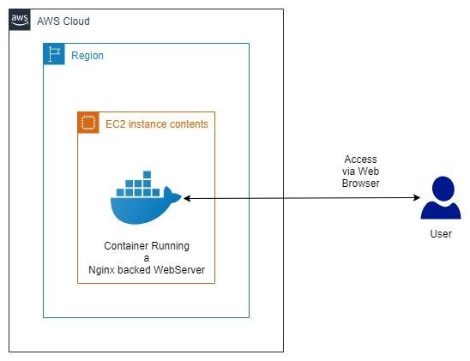

Lab Steps
Follow the steps outlined below to achieve the objective of this lab exercise:

- Log in to the AWS Console and go to EC2 Service.
- In the EC2 Service dashboard, click on Launch Instance button.
- In the Step 1 of Launch Instance Wizard, select Ubuntu 18.04 LTS as your AMI, and click Next.
- In the next step Choose Instance type, choose t2.micro as your instance type and click Next.
- In the step Configure Instance Details, set your IAM Role to CCL-EC2-Role, and leave the rest of the settings to their default values, and click on Review and Launch button. Once you review your configuration, click the Launch button.
- When prompts for a Keypair, you can create one if you are using PuTTY, or you can also select Proceed without Keypair, if you want to use Session Manager feature provided by AWS.
- Once your instance is launched, up and in running status, connect to your instance.
- If you want to make use of the Session Manager feature provided by AWS, select your instance, and click on the Connect button right above the instances pane, select Session Manager and click Connect.
- Once you have successfully connected to your instance, via SSM or PuTTY, make yourself as a super user and update the image:
sudo su apt update
- Once the image repos are updated, go ahead and download the Docker:
apt install docker.io -y
- In your web browser, navigate to hub.docker.com, you can sign up there to create an account.
This account, allows you to create your own custom images for your requirements, or you can also search and use existing ones that may fit your needs.
- For this lab purpose, we are going to use the docker image spacebones/doge which runs on Nginx. You can use this, or you can also explore the DockerHub for similar ones and use them.
- Pull the docker image for spacebones/doge using the following command:
docker pull spacebones/doge
- As the image is downloaded, start the website container and Redirect HTTP Port 80 to the Host with the following command:
docker run -d --name treatseekers -p 80:80 spacebones/doge
- You can verify whether the container has started and running or not, using the following command:
docker ps
Note: You should be able to find your container id, name, image, Port on which it is running, and the name of the container set to treatseekers based on our input in step 14.
- Copy the public DNS / public IP Address of your instance, from the instance dashboard, and paste it in a new browser in the following format:
http://IPaddress:80
Note: Your server should now load a Static Website, which shows up a GIF containing god along with some text.

- If the website fails to load, go back to your instance dashboard, select your instance, and in the dashboard below, click on the security group attached to your instance.
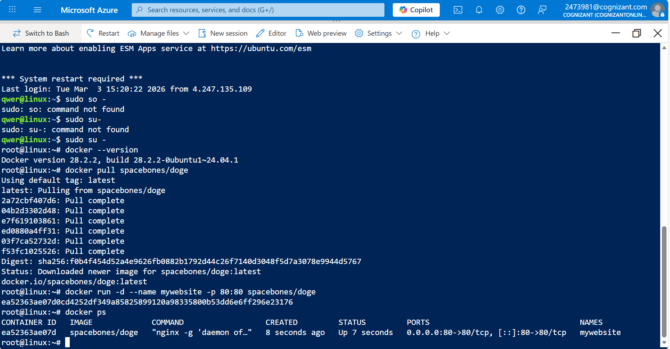
- In the Security Group, check if a Rule to allow traffic to Port 80 is available. If it is not available, click on Edit Inbound Rules, and add a new rule which allows traffic to port 80. The source can be either anywhere or Your IP (more secure, as it does not give the access to your server to the whole world).

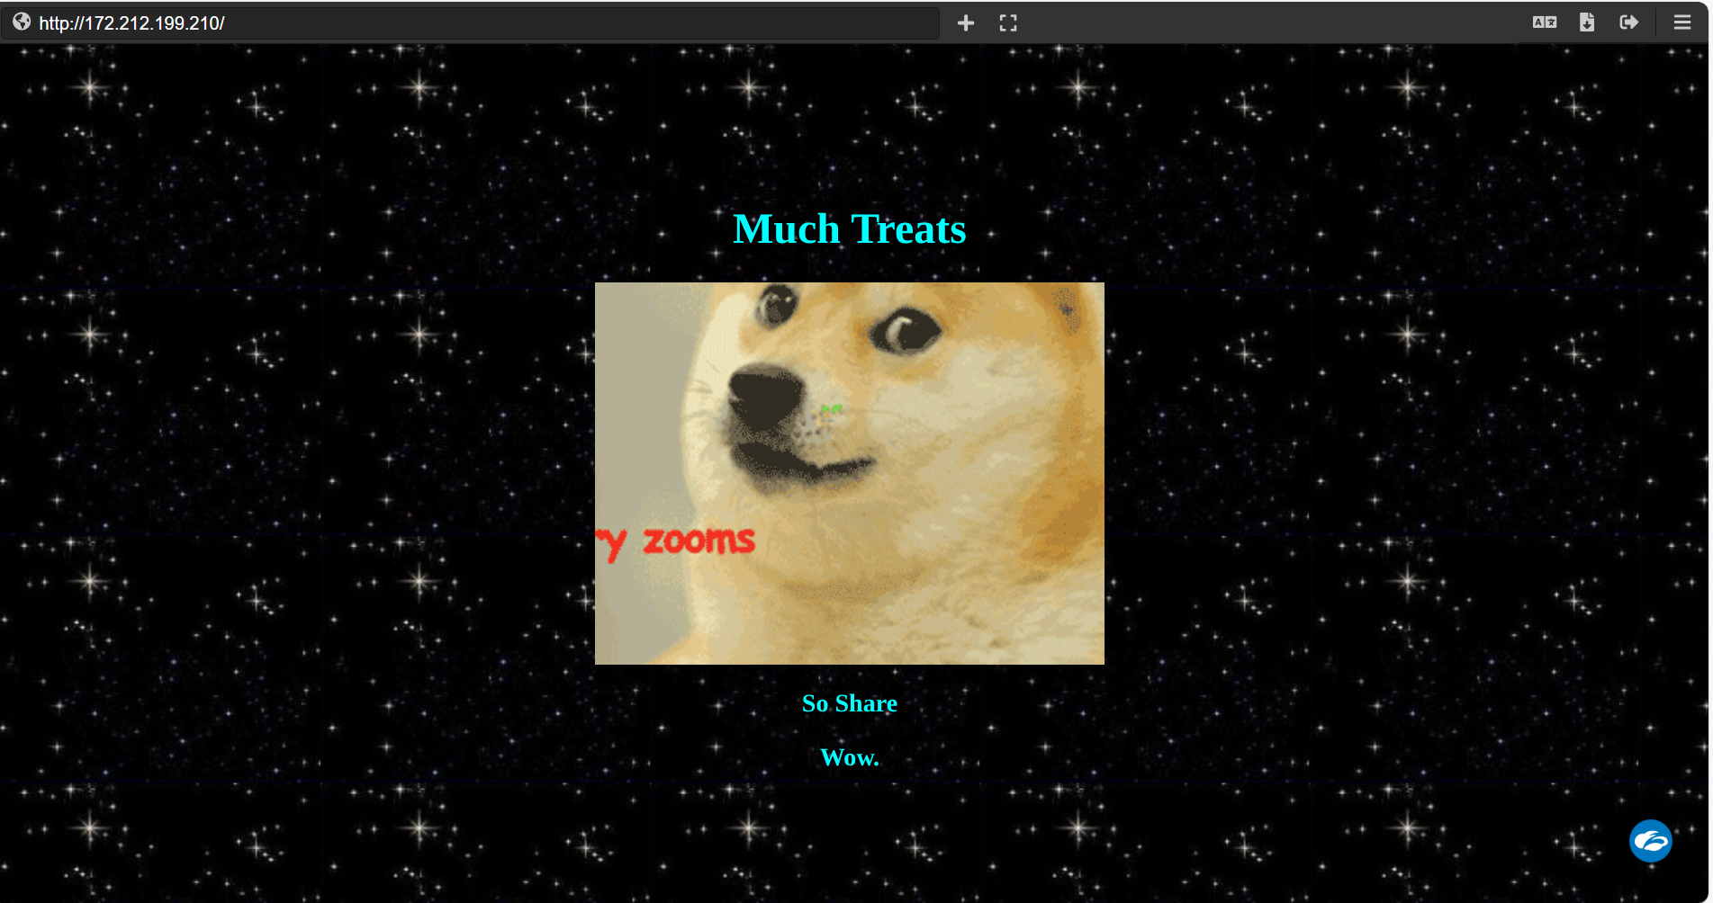
- Once you add the Rule, save it. Please refresh and check your server tab which you opened in Step 16. It should work now.

Troubleshooting
S. No | Problem | Solution
1 | Commands provided are not working | Make sure that you have launched an instance with the AMI Suggested in SOP. Commands vary for different AMIs.
2 | Webserver is not loading after starting | Make sure you have executed the steps correct, and also you have given access to the necessary ports.

Supporting References
Refer the below links for additional information:

- https://docs.aws.amazon.com/ec2/index.html
- https://docs.docker.com/

